

I wish you success

**PART 1: MULTIPLE CHOICE QUESTIONS**

Instructions for this section:

* Answer all questions in this section.
* For each question in this section, circle the correct answer

1. During electrolysis:
2. Gases may be given off or metals deposited at the electrodes
3. Gases are always given off
4. Metals are always deposited
5. Which statement is correct?
6. Metals form negative ions that move to the negative electrode
7. Metals form positive ions that move to the negative electrode
8. Metals form positive ions that move to the positive electrode
9. When copper is purified by electrolysis:
10. The positive electrode is impure copper
11. The positive electrode is pure copper
12. The negative electrode is impure copper
13. Which statement about the electrolysis of sodium chloride solution is correct?
14. Hydrogen forms at the positive electrode
15. Sodium forms at the positive electrode
16. Chlorine forms at the positive electrode
17. The products formed during the electrolysis of sulfuric acid are:
18. Hydrogen at the positive electrode and oxygen at the negative electrode
19. Hydrogen at the negative electrode and oxygen at the positive electrode
20. Hydrogen at the negative electrode and sulfur at the positive electrode
21. During electrolysis:
22. Ions lose electrons at the negative electrode and are oxidised
23. Ions gain electrons at the negative electrode and are oxidised
24. Ions lose electrons at the positive electrode and are oxidized
25. Why is cryolite used in the manufacture of aluminium?
26. It is an aluminium compound
27. It reduces the temperature needed for the process
28. It is used to make the negative electrode
29. Where does oxygen form during the manufacture of aluminium?
30. At the positive electrode
31. At the negative electrode
32. At both electrodes
33. When electroplating a metal spoon with silver:
34. The spoon should be the positive electrode
35. The silver should be the positive electrode
36. The silver should be the negative electrode
37. The half-reaction that occurs at the anode during the electrolysis of molten sodium bromide is:
38. 2 Br**-** http://www.chem.tamu.edu/class/fyp/mcquest/pics/arrw-tan.gif Br2 + 2 e**-**
39. Br2 + 2 e**-** http://www.chem.tamu.edu/class/fyp/mcquest/pics/arrw-tan.gif 2 Br**-**
40. Na+ + e**-** http://www.chem.tamu.edu/class/fyp/mcquest/pics/arrw-tan.gif Na
41. The products formed at the inert electrodes during the electrolysis of a 1.0 M magnesium iodide solution are ...
42. Hydrogen, hydroxide ion, hydronium and oxygen.
43. Magnesium, hydronium ion and oxygen
44. Hydrogen and iodine molecule
45. Magnesium and iodine
46. The product that would be formed at the graphite anode during the electrolysis of a concentrated aqueous solution of potassium chloride would be ...
47. Oxygen gas.
48. Potassium.
49. chlorine gas
50. hydrogen gas

**PART2: STRUCTURED QUESTIONS**

Instruction to this section: answer all the questions in the space provided.

1. The diagram shows the apparatus used to electrolyse fused lead (II) bromide.

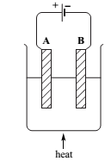

1. Label the electrodes A and B
2. The wires connected to the electrodes are made of copper.

Explain why copper conducts electricity.

.......................................................................................................................................

.......................................................................................................................................

1. Explain why electrolysis does not occur unless the lead (II) bromide is molten.

....................................................................................................................................................................................................................................................................................

1. Write the ionic half equation of
2. Electrode A……………………………………….……………………………
3. Electrode B……………………………………………………………………
4. What is formed at the
5. Electrode A …………………………………………………………………..
6. Electrode B ……….………………………………………………………….
7. What observation do you see at electrode A …………………………………………………………………………………………
8. In an experiment using the same apparatus, the amount of charge passed was 0.10 faraday
   1. Calculate the maximum amount, in moles, of each substance formed.

Amount of Pb.............................................................................................................

....................................................................................................................................

Amount of Br2…………………………………………………………………..

……………………………........................................................................................

1. Calculate the mass of bromine formed.

....................................................................................................................................................................................................................................................................

1. In industry, aluminum is extracted from alumina (purified bauxite) by means of electrolysis. An outline diagram of the cell is shown below.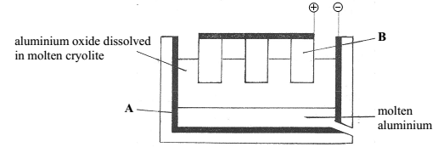
2. Name the ore of aluminium …………………………………………………………………………………………
3. Why can’t aluminium be extracted by heating aluminium oxide with carbon)? ……………………………………………………………………………..............................................................................................................................................................
4. Of what material are the electrodes A and B made?

………………………………………………………………………………………………

1. Give one reason why aluminium oxide is dissolved in molten cryolite.

………………………………………………………………………………………

1. Write the ionic half equation for the formation of aluminium at electrode A.

………………………………………………………………………………………

1. Which gas is initially liberated at electrode B?

…………………………………………………………………………………………

1. Electrodes B have to be replaced occasionally. Why is this?

…………………………………………………………………………………………

1. Give two use of aluminium and state the property on which each use depends.

……………………………………………………………………………………………………………………………………………………………………………………

1. Extraction of aluminium is more expensive than extraction of iron. Why ?

……………………………………………………………………………………………………………………………………………………………………………………

1. Calculate the number of Faradays required to deposit 1.8kg of aluminium.

………………………………………………………………………………………………………………………………………………………………………………………………………………………………………………………………………………

1. Two form3 students in 26 June secondary school tried to coat an iron key with copper using electrolysis. They set up the apparatus as shown in diagrams 1 and 2 below.

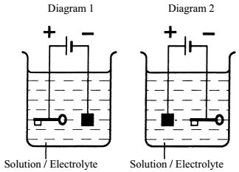

1. In which apparatus would the metal key be electroplated with copper?

Diagram _____

1. Give two reasons why objects made of iron are electroplated.

………………………………………………………………………………………………………………………………………………………………………………………………

1. Suggest the name of a solution which would be suitable as an electrolyte in this

Experiment.

……………………………………………………………………………………………

1. Put a next to the ionic half equation that represents the plating of copper on the iron key.

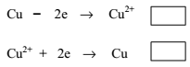

1. Calculate the number of Faradays required to plate 0.127g of copper.

……………………………………………………………………………………………………………………………………………………………………………………………………………………………………………………………………………………………

1. The diagram shows a Hofmann Voltammeter which is a suitable apparatus to collect the gases liberated during the electrolysis of acidified water, (dilute sulfuric acid).

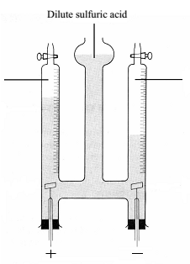

1. Label the names of the gases.
2. Fill in the table of results below

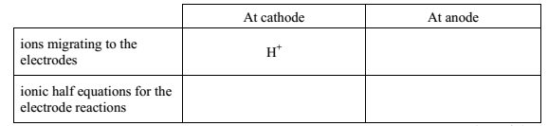

1. Why sulphuric acid was added to water during electrolysis ………………………………………………………………………………………………………………………………………………………………………………………………
2. In another experiment, an electric charge of 1930 coulombs was passed through a solution of silver nitrate.
   1. Convert 1930 coulombs into Faradays ………………………………………………………………………………………………………………………………………………………………………………
3. Calculate the mass of silver deposited this cathode equation: **Ag+ + e- → Ag**

…………………………………………………………………………………………………………………………………………………………………………………………..........................................................................................................

1. Concentrated solution of sodium chloride can be electrolyzed as shown in this diagram

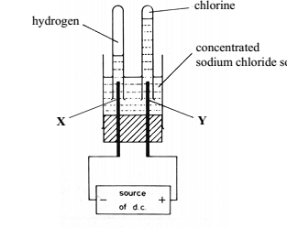

1. Give the name of electrodes X and Y on the diagram
2. Write the ionic half equation for the reaction at
3. Electrode Y………………………………………………………………………
4. Electrode X………………………………………………………………………
5. If a current of 0.41 amperes flows for 20 minutes:
   1. Calculate the electrical charge in coulombs ……………………………………………………………………………………………………………………………………………………………………………
   2. Convert the answer to Faradays ……………………………………………………………………………………………………………………………………………………………………………..
6. Copper can be purified using electricity as follows. 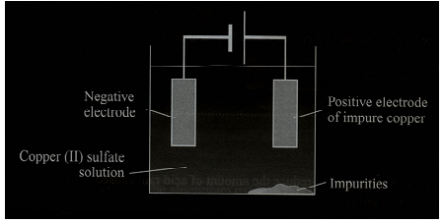
7. By what process is copper normally extracted from its ore? …………………………………………………………………………..
8. What is the name given to the electrical process by which copper is purified? ………………………………………………………………………………………………
9. State three other applications of the process in (ii) above.

………………………………………..……………………………………………………

………………………………………..……………………………………………………..

1. Give one advantage of using purified copper instead of impure copper. ……………………………………………………………………………………………
2. Magnesium sulphate solution was electrolyzed using platinum electrodes.

Write the half equation at the:

Cathode: ……………………………………………..……………………………………

Anode: ……………………………………………………………………………………

7. The diagram below shows how impure copper is refined by electrolysis.

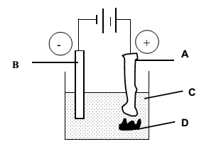

1. Give the material s that can be used to make electrodes A and B

Electrode A…………………………………………………

Electrode B…………………………..………………………

1. Identify substance C and D

Substance C…………………………………………………

Substance D…………………………………………………

1. Write the ionic equation for the reaction taking place at the anode……………………………………………………....................

Cathode ………………………………………………………………...

1. What is the economic importance of substance D ………………………………………………………………………………………………
2. What observation will be seen at the

Electrode A ……………………………………………………………………………....

Electrode B …………………………………………………………………………………

8. Form4 students in 26 June secondary are going to electroplate a teaspoon made of nickel with silver. The students are using an electrolyte of silver nitrate (AgNO3) solution. They set up the apparatus as shown in the diagram below.

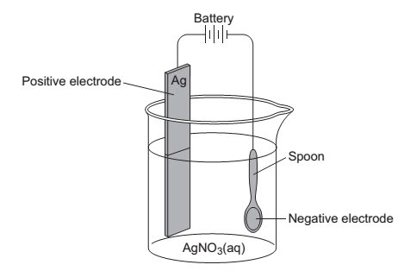

1. Define :
2. Electrolysis ………………………………………………………………………..

……………………………………………………………………………………..

1. Electrolyte ………………………………………………………………………..

……………………………………………………………………………………

1. Electroplating ……………………………………………………………………

……………………………………………………………………………………..

1. Solid silver nitrate, AgNO3(s), does not conduct electricity because the ions …………….

Choose the correct answer in the box to complete the sentence.

1. _____________is added to AgNO3(s) to turn it into AgNO3 (aq)?
2. Petrol B. Alcohol C. Water
3. silver ions move to the negative electrode because they have ____________________
4. No charge B. A negative charge C. A positive charge
5. when silver ions reach the negative electrode they turn into silver
6. Atoms B. Compounds C. Molecules